PERSONAL INFORMATION | Noha Ham
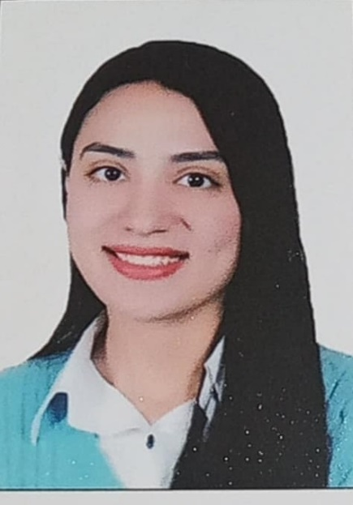 | Assistant Lecturer, Nutrition and Food Sciences, Home Economic, Faculty of Specific Education, Assiut University, Egypt.
 | (+20) 1278173350
 | nohagaber@aun.edu.eg
 | https://www.aun.edu.eg/specific-education/noha-gaber-rahby
WhatsApp (+20)1278173350
Gender Female
Date of birth 20/01/1998
Nationality Egyptian

JOB  personal statement | Assistant Lecturer, Nutrition and Food Sciences (2021-Present)  Married

WORK EXPERIENCE

Dec, 2022 – Now  July 2021 – Nov 2022 | Assistant Lecturer at Nutrition and Food Sciences, Home Economic department, Faculty of Specific Education, Assiut University, Egypt.
 | Experienced Demonstrator over 2 years of experience in teaching undergraduate at Nutrition and Food Sciences, Home Economic department, Faculty of Specific Education, Assiut University, Egypt.

EDUCATION AND TRAINING

Nov, 2022  Jan, 2022  2021-2022  2020-2021  2020  2020  2020 | - Master’s of Nutrition and Food Sciences, Home Economic department, Faculty of Specific Education, Assiut University  - University staff preparation course certificate  - Six certificates on Capacity development of faculty members relating to research and teaching  - Pre-master's in Nutrition and Food Sciences, Home Economic Department, Faculty of Specific Education, Assiut University, Assiut, Egypt  - Digital transformation course, Assiut University, Egypt  - Measurement tools course, Assiut University, Egypt  - Bachelor in Home Economic department, Faculty of Specific Education, Assiut University

PERSONAL SKILLS
- Reading
- Problem solving
- Creative discussion
- Camp organization
- Conference organization

PROGRAMMING SKILLS

- Combining nutrition and technology through mobile apps to provide personalized dietary plans to help individuals gain weight.

LANGUAGE SKILLS

- Arabic (Excellent)
- English (Very good)

SOFT SKILLS

- Ability to work in groups
- Work under stress
- Good Research Abilities
- Planning and organization
- Interpersonal skills
- Technological instruction
- Strong collaborator
- Creative learning strategies

ADDITIONAL INFORMATION

Publications  Projects and Seminars | 1. N. G. Rahby, N. S. Esaq, N. N. Esaq, and S. M. Eldeen, "Using Mobile Application to Improve the Cultural and Nutritional Status of Underweight Patients," South-South Dialogue, vol. 6, no. 17, pp. 323-343, 2023.  Contributed to many presentations for undergraduate practical courses.  Graduation Project: Design and implementation of a clothing product, specifically a graduation robe.  More than seven seminars related to my master's thesis topic.  Nutrition and Food Sciences - Home Economic practical courses (as a teacher).

